Vertical Angles
# Source: AI Source: Provided by: [Data Path: Persons Table -> ID Column: 1, Name_En Column: Motasem Essam] -> From: [ChatGPT] on [7/25/2026]
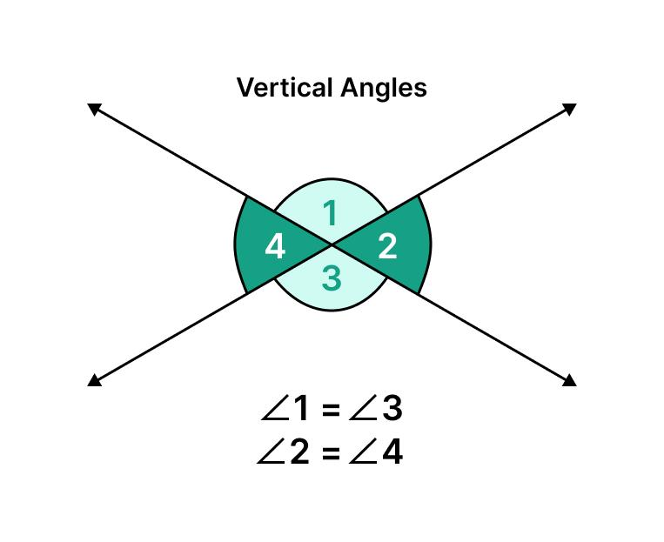
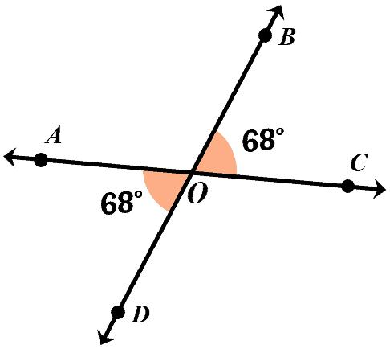
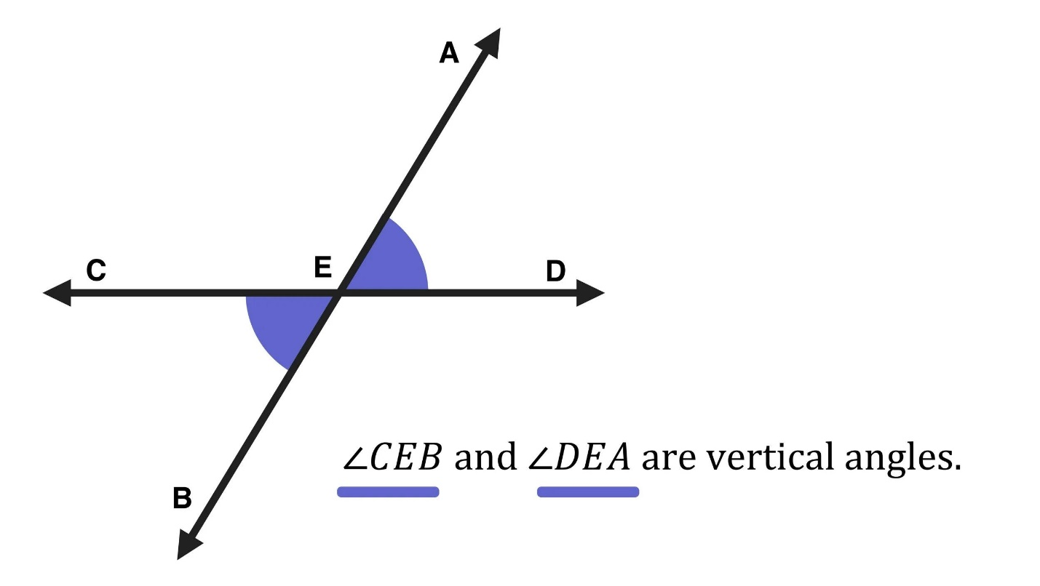
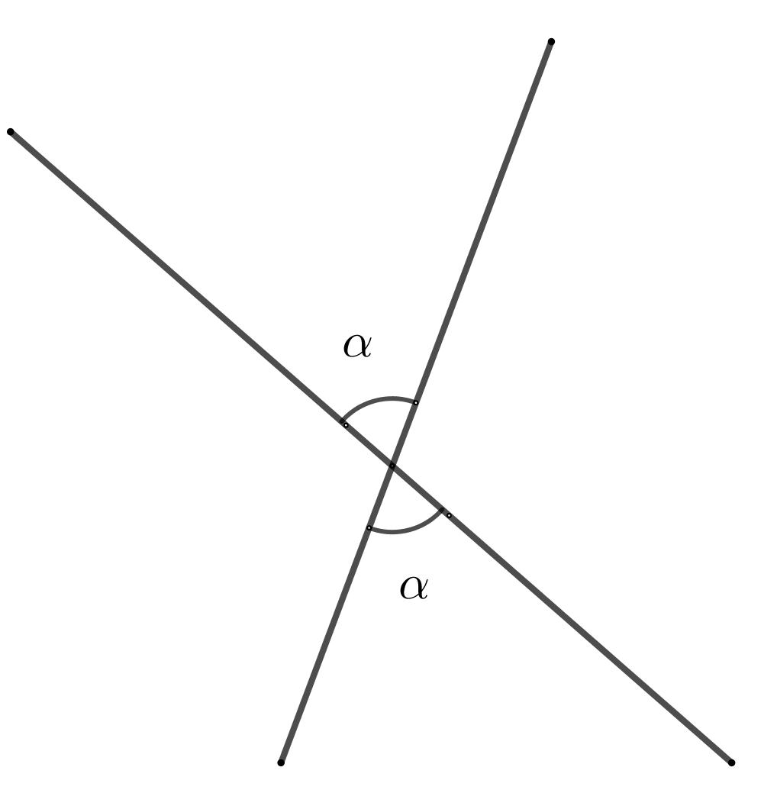
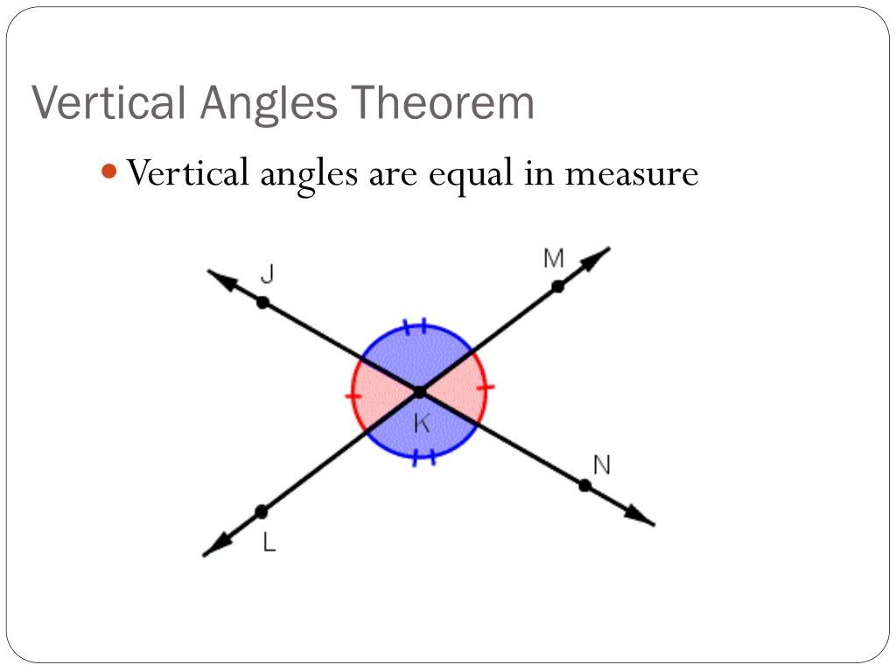
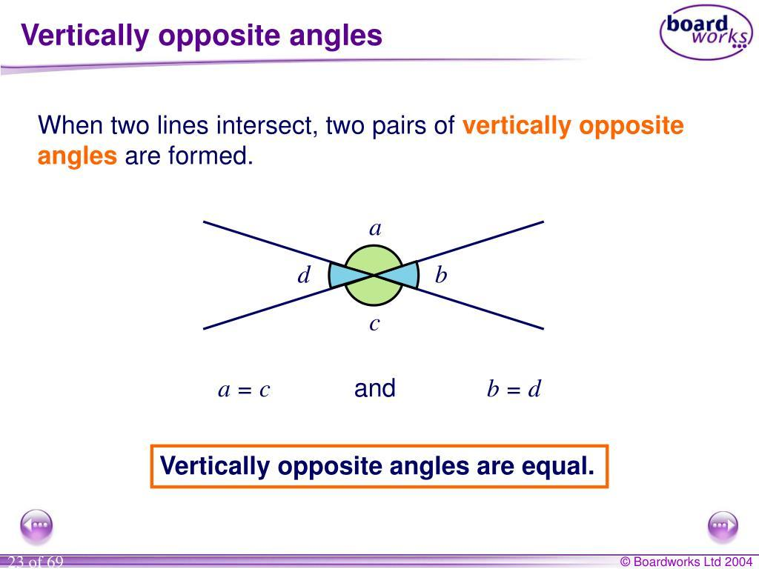

Definition
# Source: AI Source: Provided by: [Data Path: Persons Table -> ID Column: 1, Name_En Column: Motasem Essam] -> From: [ChatGPT] on [7/25/2026]
Vertical Angles are a pair of opposite angles formed when two lines intersect. They share the same vertex but do not share any common sides.
Vertical angles are always equal in measure (congruent).

Characteristics
# Source: AI Source: Provided by: [Data Path: Persons Table -> ID Column: 1, Name_En Column: Motasem Essam] -> From: [ChatGPT] on [7/25/2026]
Vertical angles:
- Are formed by two intersecting lines.
- Share the same vertex.
- Are located opposite each other.
- Do not share a common side.
- Always have equal measures.
- Their sides are opposite rays.

Illustration
# Source: AI Source: Provided by: [Data Path: Persons Table -> ID Column: 1, Name_En Column: Motasem Essam] -> From: [ChatGPT] on [7/25/2026]
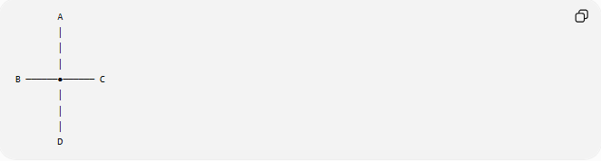
A
│
│
│
B ──────●────── C
│
│
│
D
The opposite angle pairs are:
$$∠AOB$$
and
$$∠COD$$
They are vertical angles.
Also:
$$∠AOC$$
and
$$∠BOD$$
are vertical angles.

Mathematical Representation
# Source: AI Source: Provided by: [Data Path: Persons Table -> ID Column: 1, Name_En Column: Motasem Essam] -> From: [ChatGPT] on [7/25/2026]
If two lines intersect at point (O):
$$AC$$
and
$$BD$$
then:
$$∠AOB≅∠COD$$
and:
$$∠AOC≅∠BOD$$
The symbol:
$$≅$$
means congruent (equal in measure).

Vertical Angle Theorem

Theorem
# Source: AI Source: Provided by: [Data Path: Persons Table -> ID Column: 1, Name_En Column: Motasem Essam] -> From: [ChatGPT] on [7/25/2026]
When two lines intersect, the pairs of vertical angles are always congruent.
If:
$$∠1$$
and
$$∠3$$
are vertical angles, then:
$$m∠1=m∠3$$

Proof Idea
# Source: AI Source: Provided by: [Data Path: Persons Table -> ID Column: 1, Name_En Column: Motasem Essam] -> From: [ChatGPT] on [7/25/2026]
Two adjacent angles forming a straight line are supplementary.
Example:
$$∠1+∠2={180}^{∘}$$
and:
$$∠3+∠2={180}^{∘}$$
Since both contain the same angle:
$$∠2$$
we get:
$$∠1=∠3$$
Therefore, vertical angles are equal.

Example
# Source: AI Source: Provided by: [Data Path: Persons Table -> ID Column: 1, Name_En Column: Motasem Essam] -> From: [ChatGPT] on [7/25/2026]
Two lines intersect:
$$m∠1={75}^{∘}$$
Find the vertical angle.
Because vertical angles are equal:
$$m∠3={75}^{∘}$$

Finding Unknown Angles
# Source: AI Source: Provided by: [Data Path: Persons Table -> ID Column: 1, Name_En Column: Motasem Essam] -> From: [ChatGPT] on [7/25/2026]
Example:
Two vertical angles are:
$${\left(3x+15\right)}^{∘}$$
and
$${\left(5x-25\right)}^{∘}$$
Because they are vertical:
$$3x+15=5x-25$$
Solve:
$$40=2x$$
$$x=20$$
Angle measure:
$$3\left(20\right)+15={75}^{∘}$$
Therefore:
$$∠1=∠3={75}^{∘}$$

Vertical Angles with Intersecting Lines
# Source: AI Source: Provided by: [Data Path: Persons Table -> ID Column: 1, Name_En Column: Motasem Essam] -> From: [ChatGPT] on [7/25/2026]
When two lines intersect, they create four angles:
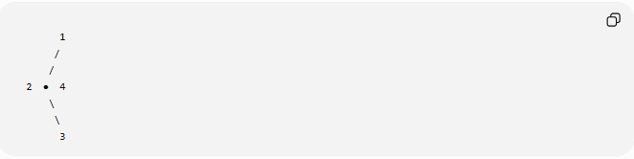
1
/
/
2 ● 4
\
\
3
Relationships:
$$∠1=∠3$$
$$∠2=∠4$$
Adjacent angles are supplementary:
$$∠1+∠2={180}^{∘}$$

Real-World Examples
# Source: AI Source: Provided by: [Data Path: Persons Table -> ID Column: 1, Name_En Column: Motasem Essam] -> From: [ChatGPT] on [7/25/2026]
Vertical angles appear in:
- Crossing roads.
- Scissors blades crossing.
- X-shaped structures.
- Intersections of cables.
- Bridge frameworks.
- Construction layouts.
- Surveying measurements.

Applications
# Source: AI Source: Provided by: [Data Path: Persons Table -> ID Column: 1, Name_En Column: Motasem Essam] -> From: [ChatGPT] on [7/25/2026]
Vertical angles are used in:
- Plane Geometry
- Coordinate Geometry
- Engineering
- Architecture
- Construction
- Surveying
- CAD (Computer-Aided Design)
- Technical Drawing
- Robotics
- Computer Graphics

Advantages
# Source: AI Source: Provided by: [Data Path: Persons Table -> ID Column: 1, Name_En Column: Motasem Essam] -> From: [ChatGPT] on [7/25/2026]
Studying vertical angles helps to:
- Find unknown angle measures.
- Solve geometric proofs.
- Analyze intersecting lines.
- Understand angle relationships.
- Simplify geometry calculations.

Limitations
# Source: AI Source: Provided by: [Data Path: Persons Table -> ID Column: 1, Name_En Column: Motasem Essam] -> From: [ChatGPT] on [7/25/2026]
Vertical angles:
- Require two intersecting lines.
- Must be opposite angles.
- Cannot share a side.
- Are not formed by parallel lines alone.

Comparison with Other Angle Relationships
# Source: AI Source: Provided by: [Data Path: Persons Table -> ID Column: 1, Name_En Column: Motasem Essam] -> From: [ChatGPT] on [7/25/2026]
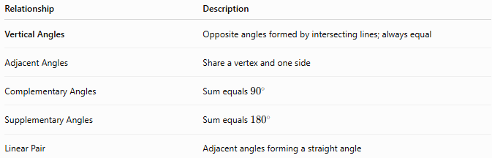
Relationship | Description
Vertical Angles | Opposite angles formed by intersecting lines; always equal
Adjacent Angles | Share a vertex and one side
Complementary Angles | Sum equals ${90}^{∘}$
Supplementary Angles | Sum equals ${180}^{∘}$
Linear Pair | Adjacent angles forming a straight angle

Key Points
# Source: AI Source: Provided by: [Data Path: Persons Table -> ID Column: 1, Name_En Column: Motasem Essam] -> From: [ChatGPT] on [7/25/2026]
- Vertical Angles are opposite angles formed by two intersecting lines.
- They share the same vertex.
- They do not share a side.
- Vertical angles are always equal:
$$m∠1=m∠3$$
- Adjacent angles formed by the same intersection are supplementary:
$${180}^{∘}$$

Conclusion
# Source: AI Source: Provided by: [Data Path: Persons Table -> ID Column: 1, Name_En Column: Motasem Essam] -> From: [ChatGPT] on [7/25/2026]
Vertical Angles are pairs of opposite angles created when two lines intersect. They share a common vertex but have no common sides, and they are always equal in measure. The Vertical Angle Theorem is one of the fundamental principles of geometry and is widely used in plane geometry, coordinate geometry, engineering, architecture, construction, surveying, CAD, robotics, and computer graphics to determine unknown angles and analyze intersecting geometric structures.

